**DAWOOD UNIVERSITY OF ENGINEERING & TECHNOLOGY**

**M.A JINNAH ROAD KARACHI-74800 (PAKISTAN)**

**FACULTY OF INFORMATION & COMPUTING SCIENCES**

**DEPARTMENT OF COMPUTER SCIENCE**

**TITLE:****DUET TRANSIT TRACKER**

**SUBMITTED BY:  
  
Fasiha(M-20/F-BSCS-12)**

**Sania(M-20/F-BSCS-13)**

**Misbah(M-20/F-BSCS-31)**

**SUPERVISED BY:** **Dr. Fida Hussain Khoso**

**Chairperson/Associate Professor**

**CO-SUPERVISED BY:**

**Dr.Asma Sanam Larik**

**DAWOOD UNIVERSITY OF ENGINEERING & TECHNOLOGY**

**M.A JINNAH ROAD KARACHI-74800 (PAKISTAN)**

**FACULTY OF INFORMATION & COMPUTING SCIENCES**

**DEPARTMENT OF COMPUTER SCIENCE**

**CERTIFICATE**

This is to certify that the work present in this FYP thesis “_______” has been carried out by group members under the supervision of ________. The work is genuine, original and in our opinion it fulfills the requirements for FYP.

**Group Members Names and ID’s**

**Fasiha(M-20/F-BSCS-12)**

**Sania(M-20/F-BSCS-13)**

**Misbah(M-20/F-BSCS-31)**

**Supervisor:**

**Dr. Fida Hussain Khoso**

**Co-Supervisor:**

**Dr.Asma Sanam Larik**

**FYP Coordinator**   **Chairperson**

______________________ ___________________________________

Dr. Asma Sanam Larik Dr. Fida Hussain Khoso

Associate Professor

**DAWOOD UNIVERSITY OF ENGINEERING & TECHNOLOGY**

**M.A JINNAH ROAD KARACHI-74800 (PAKISTAN)**

**FACULTY OF INFORMATION & COMPUTING SCIENCES**

**DEPARTMENT OF COMPUTER SCIENCE**

**DEDICATION**

This research paper Dedicated to our wonderful parents, who always support us, and their inspiration is never ending throughout the study. I am grateful for everything, from their sacrifices and encouragement.Additionally, I dedicate this work to my supervisor and co-supervisor, acknowledging their invaluable guidance without which this research would not have been possible.

A big thank you to our parents, supervisor and co-supervisor for their support and insights,

and to everyone else who has supported us.

**DAWOOD UNIVERSITY OF ENGINEERING & TECHNOLOGY**

**M.A JINNAH ROAD KARACHI-74800 (PAKISTAN)**

**FACULTY OF INFORMATION & COMPUTING SCIENCES**

**DEPARTMENT OF COMPUTER SCIENCE**

**ACKNOWLEDGEMENT**

We Would like to express our special thanks of gratitude to our parents as well as our supervisors who gave us the golden opportunity to do this wonderful project on the topic DUET Transit Tracker which also helped us in doing a lot of research and we come to know about many new things

Secondly we would also like a thank our friends who helped us a lot in finishing this project within the limited time. It helped us increase our knowledge and skills.

**DAWOOD UNIVERSITY OF ENGINEERING & TECHNOLOGY**

**M.A JINNAH ROAD KARACHI-74800 (PAKISTAN)**

**FACULTY OF INFORMATION & COMPUTING SCIENCES**

**DEPARTMENT OF COMPUTER SCIENCE**

**ABSTRACT**

The Duet Transit Tracker Project at DUET , which is expected to bring a new dimension to the educational experience, seems set change the way things are done in university. This innovation is aimed at solving the current university transport system shortcomings that include long waiting times and poor route information. The project has introduced some inspired routing algorithms, smart cards plus real-time bus monitoring that have all been developed based on the needs of users. This guarantees a transport system that may be relied upon as well as effective though easy enough to be utilized by many people because it targets academic performance as well as student welfare. Through detailed requirement analysis, projects systematically address Chatbot integration, GPS tracking design of user interfaces, communication management systems development of standards and complaints handling mechanisms. It is about university management, students as well as administrators.

**DAWOOD UNIVERSITY OF ENGINEERING & TECHNOLOGY**

**M.A JINNAH ROAD KARACHI-74800 (PAKISTAN)**

**FACULTY OF INFORMATION & COMPUTING SCIENCES**

**DEPARTMENT OF COMPUTER SCIENCE**

**TABLE OF CONTENTS**

CERTIFICATE………………………………………………..…………….………1

DEDICATION………………………………………………………………………2

ACKNOWLEDGEMENTS…………………………………………………………3

ABSTRACT…………………………………………………………………………4

TABLE OF CONTENTS……………………………………………………………5

LIST OF TABLES…………………………………………………………………..8

LIST OF FIGURES………………………………………………………………....8

1. Chapter 1-Introduction

1.1 Introduction…………………………………………………………….……..9

1.2 Background……………………………………………………………….….10

1.3 Project Vision...................................................................................................12

1.4 Problem Statement...........................................................................................12

1.5 Objectives.........................................................................................................12

1.6 Project Scope....................................................................................................13

1.7 Key Challenges………....................................................................................14

1.8 Limitations........................................................................................................14

1. Chapter 2-Requirement Analysis

2.1 Requirement Analysis ......................................................................................15

2.2 Literature Review / Existing System Study.....................................................15

2.3 Stakeholders list...............................................................................................17

2.4 Requirement Elicitation...................................................................................17

2.5 Functional Requirement...................................................................................17

2.6 Non-Functional Requirements.........................................................................18

2.7 Software development life cycle model..........................................................19

1. Chapter 3-System Design

3.1 System Design.................................................................................................20

3.2 Use Case Diagram........................................................................................... 20

3.3 Diagram……………………………………………..21

3.4 Activity Diagram.............................................................................................22

3.5 ER Diagram…................................................................................................23

* 1. Sequence Diagram...........................................................................................24

3.7 Class Diagram................................................................................................26

3.8 Gantt CHART..............................................................................................34

**CHAPTER 1**

**INTRODUCTION**

**1.1** **Introduction**The introduction outlines a project aimed at designing and developing a website/mobile application titled 'DUET Transit Tracker' to address issues in Dawood University's student transportation system. The motive originates from the hassle after missing points, resulting in wasted time and money in public transport. The statement of the problem emphasizes challenges such as the lack of punctuality in point schedules and a paper-based system of the points card generation, resulting in inconvenience for students [1]. The introduction highlights the problem statement, aims and objectives, challenges, limitations, methodology, technologies, backend APIs, chatbot including the cost of GPS integration. The scope of the research involves providing users with information about points on a specific route, including start and end points, and stops until the destination. The application aims to guide students to the nearest route and estimate time of arrival at the nearest routes of the students and notify them about possible routes if they are in a location without planned routes. The application also has a feature of a digital card generation system for both students and administration and also provides a chatbot feature for student guidance. The summary concludes with a mention of points tracking by using [4] GPS APIs for notifying nearest point stops and leveraging its routines. The individual contributions of the project include addressing issues in DUET transportation, proposing solutions, and developing an application for efficient route planning by using GPS. This project has an agile methodology and uses technologies like React.js with its libraries for the frontend and Node.js for the Backend of the application and MySQL/MongoDB for the database.

**1.2 Background**Traditional methods like issuance of cards using papers plus scheduling the routes were in use in the transport system. These ways slow down the system leading to inefficiency. Consequently, it results in missed “pick-up and drop-off points” which impacting students' academic schedules and overall university experience.  
A smart transport solution is important because the university has a dynamic environment and there is an increased need for fast, flexible and dependable transportation and the current transportation system continues to depend on human efforts, students experiencing long waiting hours, uses route information that no longer works as well as fails to get other benefits that come with easy travel. To modernize the campus commuting experience, Duet is implementing the Duet Transit Tracker project. This initiative is all about real-time bus tracking, digital card management and efficient route planning. The aim of the project is to solve the weaknesses in the existing system by making students spend less time in queues for generating their cards. This modern approach providing the general purposes of the University to protect students through creating an environment that is safe, efficient and supportive, hence promoting academic success and well-being generally".

**1.3 Project Vision**The purpose of this project is to create an advanced, reliable, effective, and easy-to-use transportation system for students. The aims of the DUET transit tracker are reducing waiting times, increasing convenience, improve overall experience and enhance accessibility. This project will improve the campus transportation by integrating smart card creation, automated routing, user feedback to make sure the transportation system is customized to the needs of students[2].  
Besides improving the efficiency and reliability of transport, the project will also make use of modern technologies. This upgraded transportation system will have long-term benefits for the entire student journey establishing a welcoming, feasible, and comfortable educational environment.

**1.4 Problem Statement**

Students face difficulties with card generation, limited bus routes, and real-time bus location monitoring.

**Manual Card Generation:**

A paper-based system for card generation is a time-taking process, causing delays in card distribution.

**Inefficient Processing of Student Card Requests and Deadline Management by Administrators:**

The current card generation system is also difficult for administrators as it has an inefficient processing of card requests and deadline management.

**Lack of Real-Time Bus Location Tracking:**

There is no way of finding out where exactly a particular bus is at any given moment. This situation is further worsened because there is limited availability of bus timetable and route information leading to challenges among students. Also, there is no way of finding out where exactly a particular bus is at any given moment.

**1.5 Objectives**

**Efficient Card Registering:**   
• Helps register students' ID cards quickly.   
• Offers easy-to-operate digital cards  
**Engaging Path Tracing:**  
Information on students' path tracing provided interactively;   
• Full info on point-to-point routes.   
• Consists of destinations, schedules as well as time taken.  
**Monitoring of buses:**   
• Track the buses as they travel in real-time.   
• Ensures that students are always informed about their arrival schedules.  
**User-focused model of interface building:**   
• Make a usable website or app.   
• Make sure that it is very easy to get around for students thereby meeting their needs.   
• Conduct smooth integration with the transport system.  
**User Feedback Integration:**   
Make use of the feedback to help in pinpointing where the areas that needs improvement lies within the transportation system.   
**Enhanced Operational Efficiency:**   
• A user-friendly administration interface is introduced.   
• Management of bus routes, updating of software and card requests.

The goals set for the Duet Transit Tracker project will result in a reliable, effective and up-to-date road system at DUET University, designed to meet all the demands of its students thereby making their entire campus stay much more pleasant and memorable.

**1.6 Project Scope :**

The project acknowledges the difficulties in managing the vast campus, particularly with dealing with transportation and has an intention of making campus commuting experience better. The project is planning to use a combined strategy which helps in lowering these difficulties and increasing students’ comfort levels. The purpose of the DUET transit tracker is to provide students with a convenient means of requesting transport services within a given location. It features a web-based user interface that is available to any student or administration who needs to use it. To facilitate ease of access for students and administration staff members, there is a login form for students and admin for the authentication purpose to the application. The system offers streamlined request management processes including deadline setting, complaint handling and GPS tracking ability. The workflow comprises of Sign-up, Sign-in, student and admin Dashboard functionalities with a desired output of a fully functional web app; A Chat bot incorporating into the application for transportation and application related queries; and Comprehensive documentation customize for different stakeholders. Quality standards cover “best practices, “user testing, “feedback integration, as well as continuous improvement. “Frequent updates and feedback gathering are involved in a communication plan for phases of development, testing, deployment, and feedback.

**1.7 Key Challenges:**

To ensure the successful implementation and operation of the Duet transit Tracker project at Dawood university, it is essential to overcome some key barriers., these matter requires more careful considerations and strategic approach such that they have an impact on three areas: technology, operations, or user acceptance;   
**Integration of Advanced technology:** Incorporating cutting-edge technologies such as real-time data processing, AI algorithms and GPS, presents a significant difficulty, technical know-how in system architecture and software development are required for seamless integration of these technologies thus giving end users accurate and reliable information.  
**Scalability and Performance:** When evaluating an architecture for any purpose, it is important to consider the system’s scalability and performance. In order to support the ever-changing campus life, what you require is a scalable architecture which can receive elevated loads yet remain reactive under high usage.  
**Data Security and Privacy:** Privacy and data security are extremely important measures to prevent unauthorized access and breaches of sensitive user data, such as travel records and personal information into databases. In this regard, strong safety and protection aspects must be implemented which could be inclusive of encryption systems, various levels of passwords as well as periodic checks on its effectiveness to ensure that the confidentiality principle remains untainted.

**User welcome and coaching:** A major problem is to ensure broad usage among administrators and students. In order to maximize system usability encourage user adoption, attending to any concerns about usability, and providing guidance on how to use the system optimally.  
  
**Cross-Platform Compatibility:** refers to keeping things the same and maintaining compatibility between different platforms; for example mobile phones and web browsers. For the platform to remain constant it must be thoroughly tested so that there is a common user experience and it remains constant in performance across all channels.

**1.8 Limitations:****Technology Dependency:** This is the risk of having to rely on technology in our transport system which may be disrupted if it fails. Services of this kind shouldn’t fail at any given time but stay intact forever.  
**Data Security Concerns:** When dealing with sensitive student details, that should be kept private to prevent from unauthorized access.  
**Operational Dependencies**: Where optimum route scheduling and reliability are concerned, making use of the university's transit system is important. Thus, any operational inefficiency or system outages would make it difficult to obtain accurate information from the tracking tool that provides real-time data.  
**Transition to Mobile App:**  Moving from website to an app is not easy because this involves building applications suitable for different operating systems with their respective app stores and making sure students enjoy the same experience on all platforms.

**CHAPTER 2**

**REQUIREMENT ANALYSIS**

* 1. **Requirement Analysis**

Communication Plan

Quality Standards   
Deliverable

User Interface (UI) and User Experience (UX)   
Chat bot Integration  
GPS Tracking   
Complaint Handling

* 1. **Literature Review**

1. **Bus tracking and Bus arrival time, location prediction system**

This paper is presenting a numerical approach to divine public bus arrival times using GPS information management systems. It has a purpose to save passengers time that is spent while waiting for buses, and this would be done by tracking their actual location and by providing [3]

a prediction of arrival times and for this purpose a mobile computing is used and it require central monitoring and control must be updated on regular basis. The paper get authentic information for the buses arrival times by consider the challenges that passenger faced, which shows extended wait times and disappointment. The current public transit (PMT) transport system also causes lack of certainty about bus routes, Which making passengers to depend on noises at bus stops[3]. The authors propose a new approach to integrate RFID technology into wireless sensor networks (WSN) phones for bus management, extending the read range of RFID systems and optimizing RFID [3][2] reader presentation and energy. This proposed system has three building block that are Passenger Module, Server Module, and Bus Device Module.The system predict bus arrival times and distances by using a analytical approach,[3][1] which is based on factors affecting arrival time prediction. A examination on bus tracking and breakdown management disclosed that previous systems were inefficient in providing convenient services.

**2)Bus Tracking and Arrival Prediction System:**

This project points to develop a GPS-based system which assist passengers by knowing them an predicted time of arrival of a bus to their stops. The project in Sri Lanka uses GPS trackers on buses to calculate right arrival times,[1][3] and direct towards the matters like punctuality and moderate feedback time. This project contains of a client-side application, server side, and GPS module side. The project involves hardware implementation, including GPS module design, installation, and testing [2][3].

This projects improves the efficiency of public transportation by providing real-time monitoring, passenger information, and location notifications, enhancing route scheduling and operational controls.

**3)Communicating and Transacting with Chatbots: Insights from Public Transport**

In recent times, the advancement of chatbots leads to the way of extensive use in the several productions, this comprises the reservation of event tickets, scheduling, and calendar associates[5].

They have also been seen in public transportation, with the Swiss Railway Company BLS introducing a chatbot in 2017 [5][4]. Although, challenges continue, such as users lost the option to input different ticket desires and chatbots not offering all ticket types.

In spite of their prospective for conveying and customization through machine learning,

chatbots still face limitations [5]. The advantage of chatbots in digital marketing and business depends on the capacity to understand and respond to user requests without human intervention.

**4)AI CHATBOT FOR TRANSPORTATION SYSTEM**

A chatbot is a tool that uses Natural Language Processing (NLP) and deep learning to facilitate web-based discussion through text, providing direct contact with a live human specialist through a graphical user interface.

It give large transport information and relieve travel planning for public transport users by constructing with keras library of python and TKinter for GUI [4]. The methodology of the chatbot design includes user input contrast with values of database, and engaging amaze learning techniques for model efficiency. The NLP Engine uses Natural Language Understanding (NLU) for message organizing, mining, and recognition, while for user message classification the [5] Recurrent Neural Network (RNN) algorithm LSTM is used.

Future enhancements include voice chat and web expansion to improve transportation efficiency and user experience.

1. **Factors Influencing Adoption Intention of AI Powered Chatbot for Public Transport Services within a Smart City**

The fast increase in size of a cities has creating issues like congestion, delays, and disappointment with public transportation. India is moving towards the initiatives of smart city to manage and improve the services to the citizens through AI-powered chatbot.Researchers establishes that people are more likely to use chatbots [6], if they feel easy to use or if their friends are experiencing it. It can give a great impact on the use of public transportation by reducing crowding and pollution. AI has the potential to create chatbots that can understand and respond to natural language, taking some of the workload off busy government departments and making citizens happier by providing 24/7 answers to common questions.This research paper enhance our understanding to use the chatbots and potential to improve public transport information, especially in developing countries like India [5]. It is important to have a factors like trust and anthropomorphism for developing a chatbot that work well, because it can provide real-time updates on transport status. Although this study admits some limitations, such that the study only extend people in pune, and suggests future studies could look at how often people use chatbots and their satisfaction [4].

* 1. **Stakeholder List**

**Students:** The main users of the app, students depend on it for their transport needs and to keep track of their points.  
**Administrators (Transport Staff)**: They are tasked with controlling cards requests, deadlines and all aspects of its ope-rationalization.  
**IT Department:** The IT department offers technological support and guarantees that everything runs smoothly and it is integrated into the other systems which are already in place.  
 **Security Team:** application security and how to fix any loopholes is the responsibility of the security team.  
**Quality Assurance Team:** Before deployment the Quality Assurance Team will test the functionality make sure it meets the requirements.  
**Funding Authority:** The role of the funding authority is to manage the budget and financial resources meant for the project  
**University Administration:** University administration makes sure that the project is align with university set goals and policies.

* 1. **Requirement Elicitation**

**Communication Plan**: Create a communication strategy that includes regular updates and user input gathering throughout the project phases. This will help to guarantee that the product is align with the needs and expectations of the users during the development, testing, deployment, and post-deployment phases.  
**Quality Standards** : Utilize industry best practices for developing software, such as testing procedures and code quality guidelines. To get input and make system improvements based on user needs and preferences, test the system with actual users.

**Deliverers:** Creating two separate versions of the dashboard, one for students and one for administrators, which are suited to their specific requirements, this web application should encompass all stated features together with functionalities. Make sure that Chatbot is integrated into the web application in the most efficient way.  
**User Interface (UI) and User Experience (UX):** Create a web interface that is responsive to users on various devices, taking into account both the user interface (UI) and the user experience (UX). Put simply, create a Home Page that is minimal and contains features that are simple for administrators and students to navigate.

**Chatbot Integration** : Incorporate a chatbot feature that offers users and administrator immediate assistance with transportation-related problems. The chatbot must to be able to reply by way of typical queries such general information.

**GPS Integration:** Integrate GPS functionality to track locations of transportation vehicles in real time GPS Tracking. It is essential to update students about where the vehicle is so that they can relate with ease. **Complain Handling :** Students should have a way to give feedback when they take the bus. This feedback should be accessible and viewable so that it can be acted on.

* 1. **Functional Requirements**

**Chatbot Integration** : Include a chatbot function that provides users with quick help on issues related to transportation. Through common issues like general information, the chatbot should be able to respond.   
**GPS Integration**: Incorporate GPS capabilities to monitor the real-time positions of transportation vehicles. GPS tracking: In order for pupils to relate easily, it is imperative to keep them informed about the whereabouts of the vehicle.

**Complain Handling :** Students should have a way to give feedback when we face any query. This feedback should be accessible and viewable so that it can be acted on.

**Deliverers:** Creating two separate versions of the dashboard, one for students and one for administrators, which are suited to their specific requirements, this web application should encompass all stated features together with functionalities. Make sure that Chatbot is integrated into the web application in the most efficient way.

* 1. **Non-Functional Requirements**

**User Interface (UI) and User Experience (UX):** Create a web interface that is responsive to users on various devices, taking into account both the user interface (UI) and the user experience (UX). Put simply, create a Home Page that is minimal and contains features that are simple for administrators and students to navigate.

**Communication Plan**: Provide a mechanism to guarantee users provide feedback on the project at various points during its development, testing, launch, and post-publication phases. This will take into account their expectations and needs.

**Quality Standards :** This includes following coding standards, developing quality software, managing tests, conducting them in order to get feedback and improve quality.

* 1. **Software Development Life Cycle Model:**

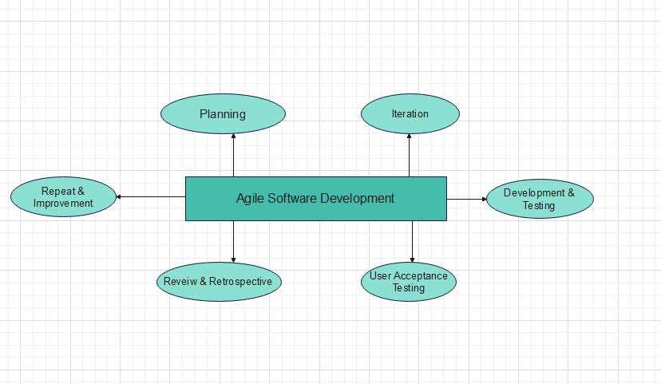

1. **Vision & Planning:**

Establish the project vision and goals, such as to enhance the student’s travel experience through real-time bus tracking. Identify stakeholders affected (students, administrator). As a [user role], I want [to do something] so that [I can achieve a benefit] format must be employed in order to generate user stories from users requirements. For example, a statement can written this way; “As a student, I want to see the arrival time of the next bus to my stop such that I can effectively plan my waiting time.”

Importance, problems and their necessities are used to prioritize user stories. Create a high level product backlog – a list of all user stories in a prioritized order.  
**2. Iteration (Sprint) :**

The current sprint’s scope is determined through a sprint planning meeting; during this meeting, a set of high-priority user stories from the product backlog’s top-most portion is selected. As such, the development team embarks on a collaborative journey regarding design, development and testing based on the chosen user stories.  
**3. Development & Testing (Throughout Sprint):**

During sprint, architects, designers, and developers collaborate closely in order to design, develop and test functionalities for that sprint. This may also include UI/UX design, web application development, integrating Geographical Positioning System (GPS) data as well as implementing chatbots. On a daily basis there are stand ups to talk about achievements and challenges faced by team members as well as to ensure that everyone is reading from the same script.Unit testing and integration testing serve the purpose of checking that single parts and their connection work as planned.

**4. User Acceptance Testing (UAT) (End of Sprint):**

In the last week of development, a few chosen students test out the new features that have been created thus far and then give their feedback. To put it another way, they were able to identify everything that would lead to user misunderstanding and prevent this program from living up to end users' expectations. The following sprint makes a list of all errors made and how to fix them.  
**5. Review & Retrospective (End of Sprint):**

Show the features that have been developed to stakeholders and collect feedback via a sprint review meeting. Use this meeting as an opportunity to validate assumptions, adjust the direction and gauge progress. During the sprint retrospective meeting, discuss processes that need to be improved for the next sprint by examining past challenges, along with the achievements that were made.

**6.Repeat & Improvement (Continuous):**

The project moves forward using various sprints; processes pass to the next sprint only after testing of the current one. Because of this method waste of resources reduced while real needs are met.

**CHAPTER 3**

**SYSTEM DESIGN**

## 3.1 System Design

The diagram illustrates a student ID card enrollment system with separate interfaces for students and administrators. Upon login, students can interact with a chatbot, view personal info, and submit feedback. Admins have additional features including real-time student location tracking, ID card approval/rejection, route updates, and complaint resolution. Overall, the system simplifies ID card enrollment for students and empowers admins with comprehensive management tools.

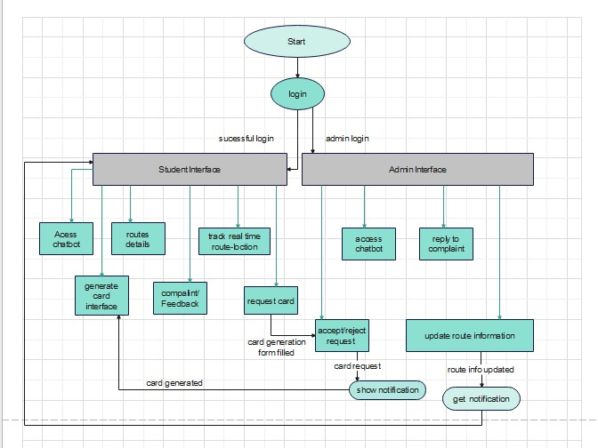

## 3.2 Use Case Diagram

The diagram illustrates a student transportation system where students can easily access bus routes, register for transport cards, track their location, and receive updates. Administrators can monitor and maintain the system, update bus routes, and manage transport card requests. It simplifies transportation for students and provides administrators with efficient management tools.

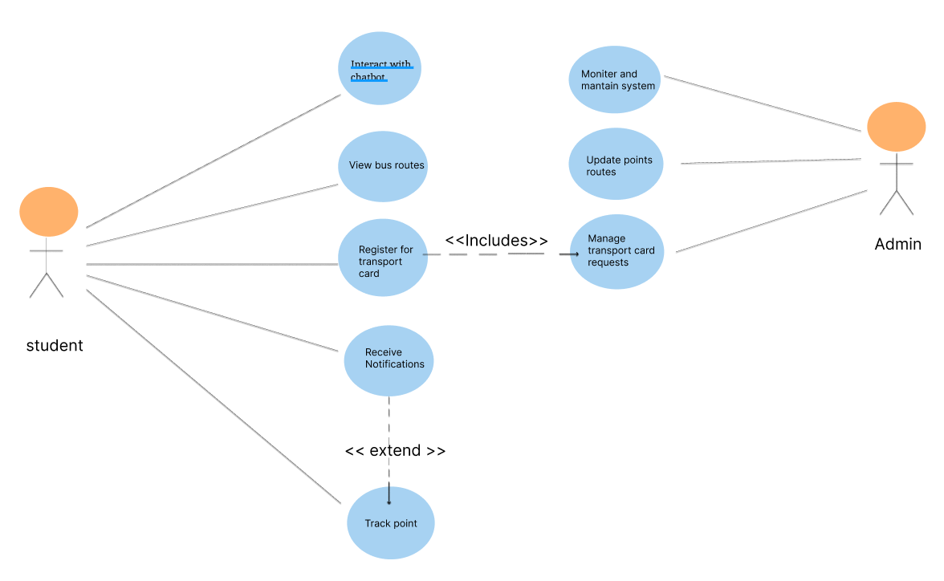

## 3.3 Data Flow Diagram

The data flow diagram illustrates the flow of information within a student ID card enrollment system. Students initiate the process by submitting requests for new ID cards, including personal details, which are transmitted to the system. Administrators utilize the provided admin dashboard to manage these requests. Students can register or log in to the system, with credentials verified against a database. Upon approval by administrators, the system generates transport cards, likely updating a database or printing cards. Additionally, students can provide feedback or lodge complaints, which are integrated into the system. In essence, this diagram portrays a streamlined process where student requests are managed efficiently, ultimately resulting in the issuance of ID cards, while also allowing for user feedback.

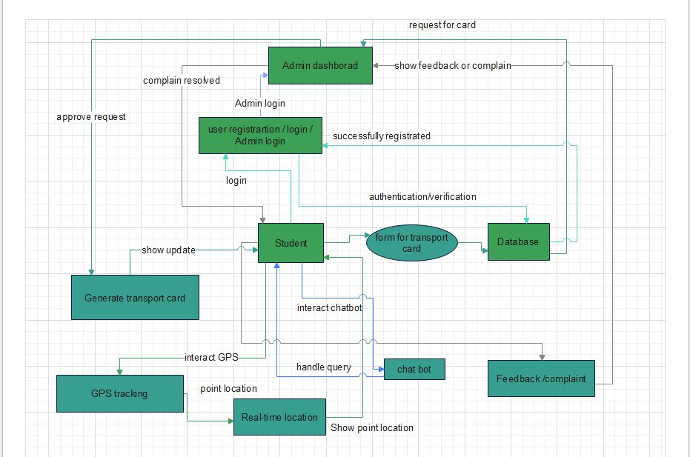

## 3.4 ER Diagram

The Entity-Relationship (ER) diagram depicts the structure of a student transportation system, showcasing the entities and relationships within the database. It outlines entities such as Student, Route, Transport Card, and Admin, each with specific attributes. Relationships like Manages (between Admin and Student/Route/Transport Card), Uses (between Student and Transport Card), and Allows access to (between Transport Card and Route) delineate how entities are interconnected. This diagram serves as a blueprint for database design, facilitating the storage and management of student, route, and administration data within the transportation system.

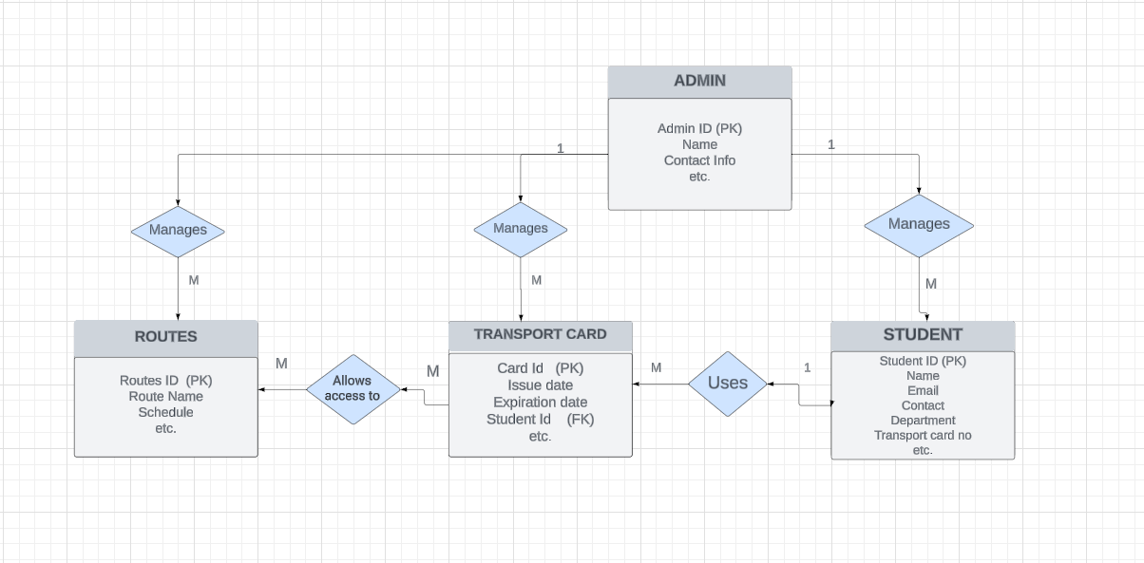

## 3.5 Sequence Diagram

## The sequence diagram illustrates the basic login process for a web application, encompassing user credential entry, validation, and the outcomes of successful or unsuccessful login attempts. Meanwhile, the concept diagram delineates a student transportation system, offering students functionalities like accessing bus routes, registering for transport cards, tracking their location, and receiving notifications. Administrators, on the other hand, can oversee system functionality, update bus routes, and manage transport card requests. This system streamlines student transportation and provides administrators with efficient tools for management and response.

**Admin Login**

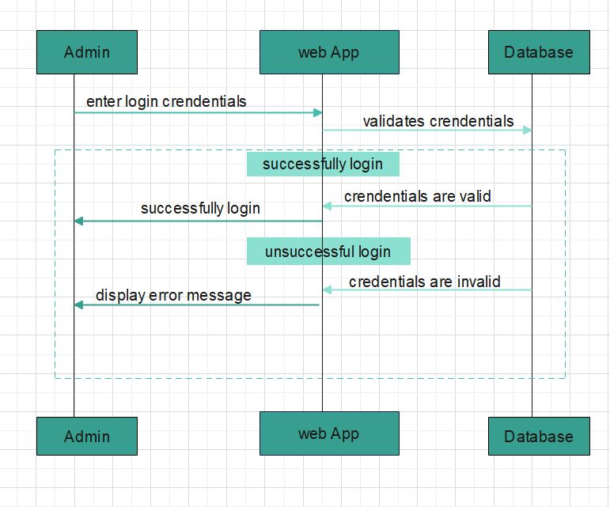  
**Student Login**  
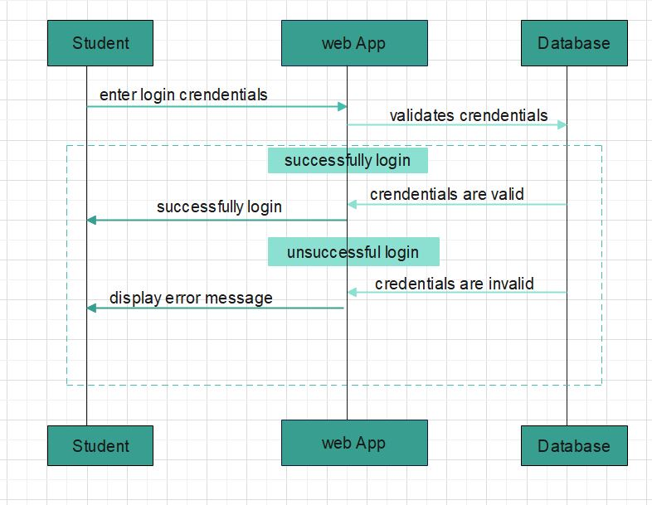

**Chat Bot Sequence**   
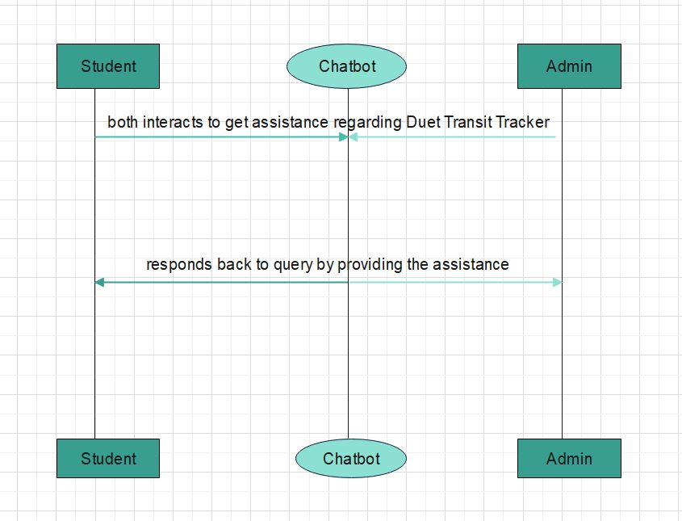  
**GPS Sequence**  
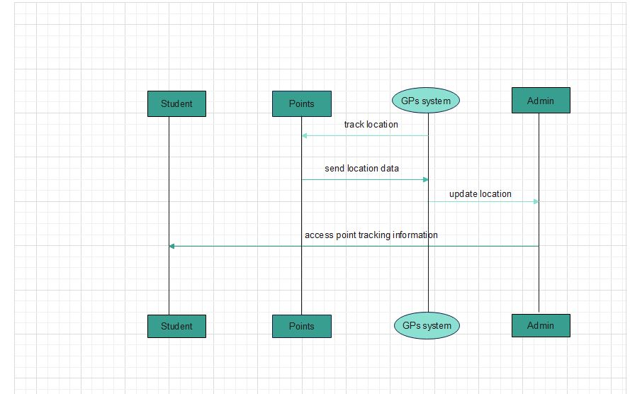

**Card Generation Sequence**   
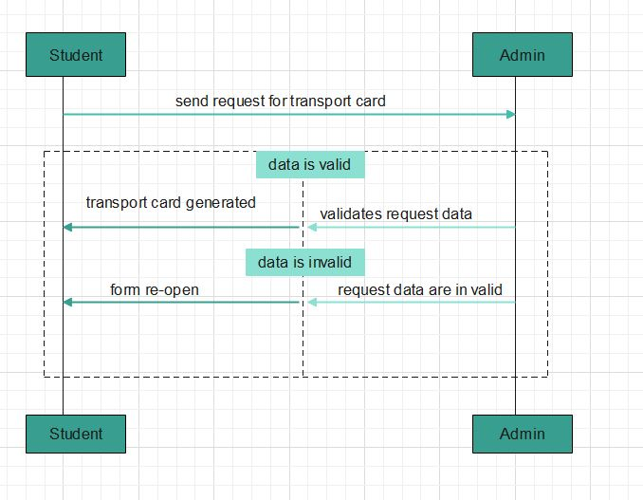

**Complain System Sequence**  
  
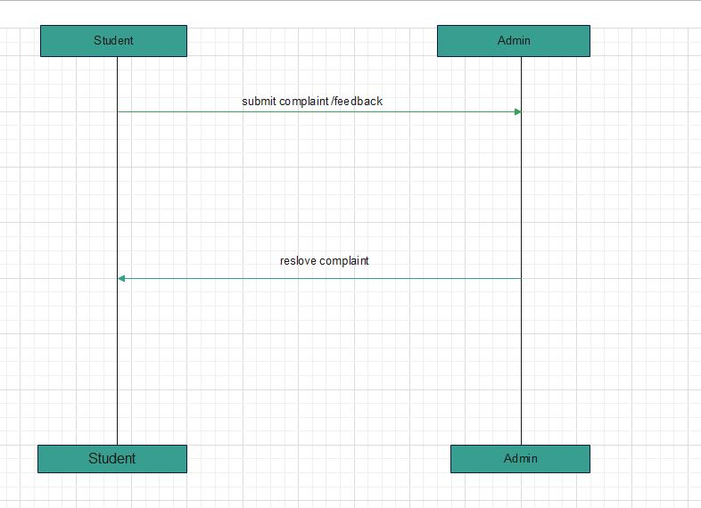

**Route Update Sequence**   
 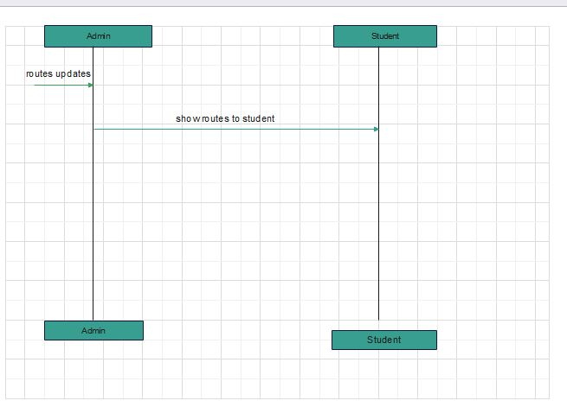

## 3.6 Class Diagram The class diagram outlines a student transportation system, with the Transportation App coordinating features like chatbot, feedback, and GPS. Students use the app for tasks like form submission and bus tracking, while admins handle form review and route updates. Point Card manages card details, and Form validates submissions. Relationships like Uses show how components interact, streamlining system operations for easier development and maintenance.

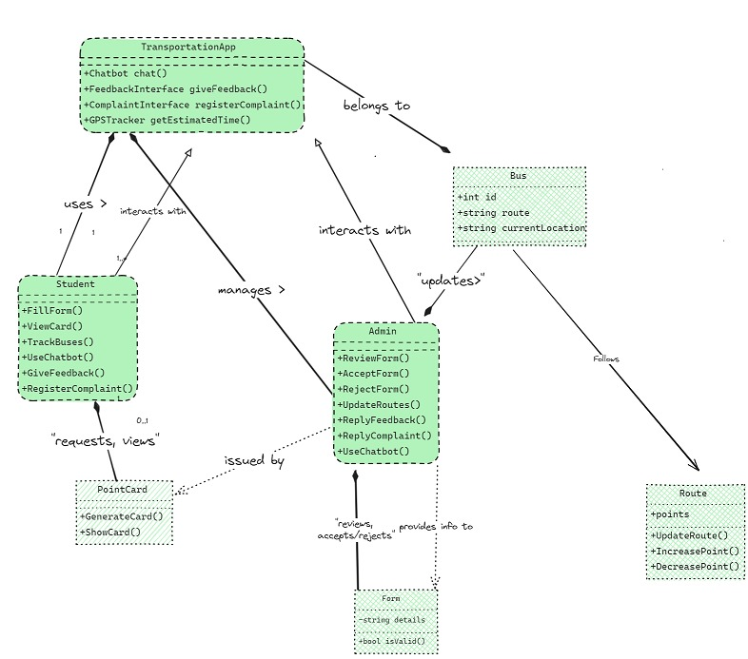

## 3.7 GANTT CHART

The Gantt chart shows the schedule for a project. It starts with planning and research, then moves to system design and development, including testing and integration. Weeks 10-13 focus on testing and deployment, followed by user feedback collection. Documentation is completed in weeks 14-15, with the project concluding in week 16 with a final presentation and report submission. This chart helps keep tasks on track and ensures timely completion.

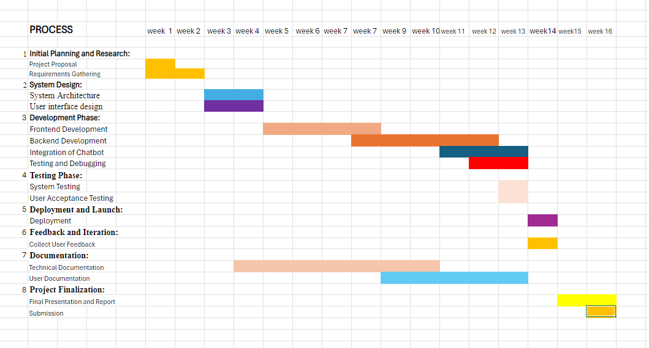

## References

[1][Wickramasinghe, W. A. S., Karunathilake, D. G. S. M., Abeywardhana, K. G. H., Senavirathna, D. C. M., Premadasa, T. W. M. P. P., Athulathmudali, A., Koswatta, K. W. R. C. W. A. M. G. S., Mohomad, M. H. H., Hasara, O. N., & Abeygunawardhana, P. (2023). Bus Tracking and Arrival Prediction System. Proceedings of the 2023 International Conference on Transportation Innovation, 25(4), 211-222.](C://Users/PMLS/Documents/Bus_Tracking_and_Arrival_Prediction_System1.pdf)

[2] [Sun, D., Luo, H., Fu, L., Liu, W., Liao, X., & Zhao, M. (2007). Predicting bus arrival time on the basis of global positioning system data. Transportation Research Record: Journal of the Transportation Research Board, 2034, 62–72.](C://Users/PMLS/Documents/Predicting_Bus_Arrival_Time_on_the_Basis_of_Global2.pdf)

[3] [Kaulage, A. N., Pingale, A., Bhoite, P., Mankar, V., & Yadav, P. (2017). Bus tracking and bus arrival time, location prediction system. International Research Journal of Engineering and Technology (IRJET), 4(5), 806-811. Retrieved from IRJET](C://Users/PMLS/Documents/Bus%20tracking%20and%20Bus%20arrival%20time,%20location%20prediction%20system%203.pdf)

[4][Gholap, P. S., Lohote, P., Belhaware, A., Barve, O., & Doke, S. (2021). AI chatbot for transportation system. International Journal of Creative Research Thoughts (IJCRT), 9(10), c908-c913. Retrieved from IJCRT](C://Users/PMLS/Documents/IJCRT2110347%20(1).pdf)

[5] [Zumstein, D., & Hundertmark, S. (2017). Communicating and transacting with chatbots: Insights from public transport. In Proceedings of the International Conferences WWW/Internet 2017 and Applied Computing 2017 (pp. 55-62). Retrieved from ResearchGate.](C://Users/PMLS/Documents/171017_Chatbots_ZumsteinHundertmark.pdf)

[6][Kuberkar, S., & Singhal, T. K. (2020). Factors influencing adoption intention of AI powered chatbot for public transport services within a smart city. International Journal on Emerging Technologies, 11(3), 948-958.](C://Users/PMLS/Documents/AI%20power%20chatbot%20for%20public%20and%20private.pdf)

[7]Mane, P. S., & Khairnar, V. (2014). Analysis of Bus Tracking System Using GPS on Smart Phones. IOSR Journal of Computer Engineering (IOSR-JCE), 16(2), 80-82.

[8]Kondguli, S. S., Dandekar, S. G., Patil, A. D., & Patil, Y. S. (2024). Bus Tracking System. International Research Journal of Modernization in Engineering Technology and Science, 06(03), 3353.

[9]Zumstein, D., & Hundertmark, S. (2017). Communicating and Transacting with Chatbots: Insights from Public Transport. In Proceedings of the International Conferences WWW/Internet 2017 and Applied Computing 2017. Lucerne, Switzerland: Institute of Communication and Marketing, Lucerne University of Applied Sciences.

[10]Bharadiya, J. P. (2023). Artificial Intelligence in Transportation Systems: A Critical Review. American Journal of Computing and Engineering, 6(1), 35–45.